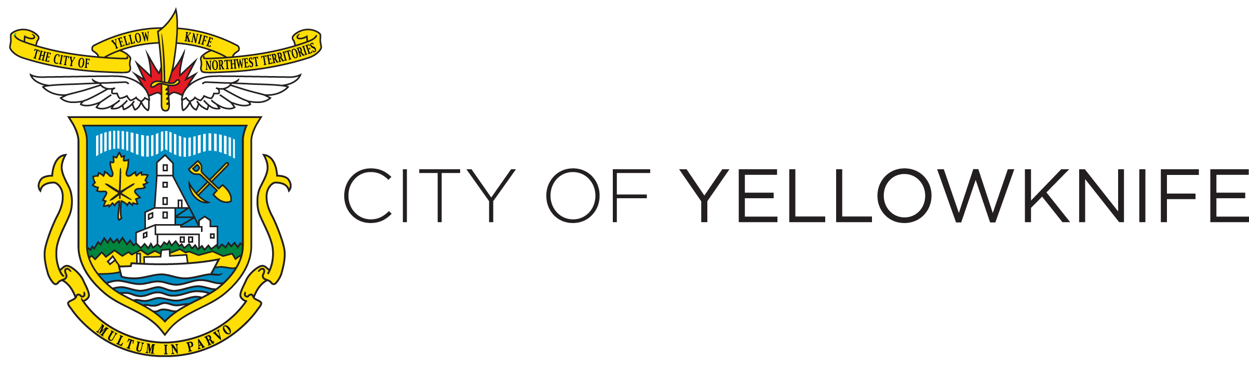

50/50 LOT – DOWNTOWN REVITILIZATION OPPORTUNITY

Terms of Reference

Docs #547925v2

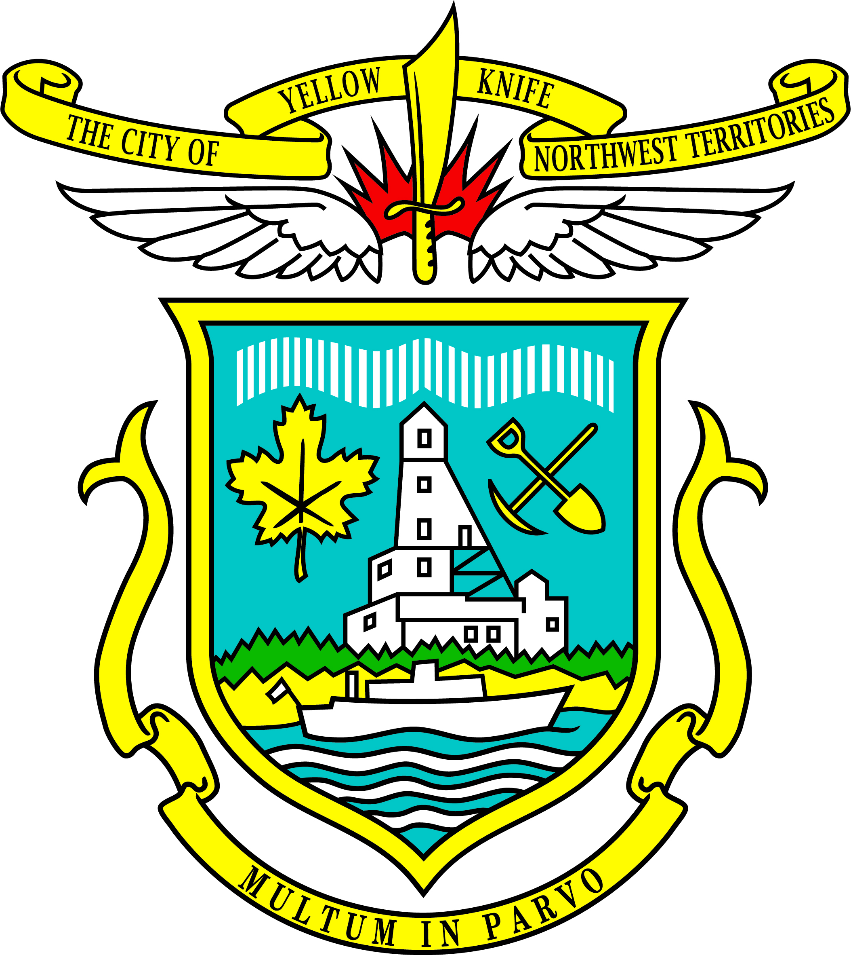
CITY OF YELLOWKNIFE
50/50 Lot – Downtown Revitalization Opportunity

TABLE OF CONTENTS

1. SITE INTRODUCTION & PURPOSE 1
2. GENERAL DEVELOPMENT GUIDELINES 1
2.1 Potential Development Site 1
2.2 Relevant Planning Documents 2
3. DELIVERABLES 2
4. RESPONSIBILITIES OF THE SUCCESSFUL PROPONENT 2
4.1 Consultation 2
4.2 Purchase Agreement 3
4.3 Development Permit and Building Permit Approval 3
5. MINIMUM ACCEPTABLE PURCHASE PRICE 3
6. EVALUATION OF DEVELOPMENT IMPACTS 3
7. TIMEFRAME 3
8. EVALUATION CRITERIA 3
9. SITE MAP 5

SITE INTRODUCTION & PURPOSE
The subject land is described as Lot 34 Block 30, more commonly known as the 50/50 lot. It currently is approved as a parking lot and is within the DT – Downtown zone. The City is inviting qualified businesses, organizations, or persons to submit a Development Proposal for the purpose of meeting Council’s goals of Downton Revitalization and Strengthening and Diversifying the Economy. The Development Proposal shall reflect the goals of City Council. The successful proponent will be able to purchase/lease the land.

The area for development will be made available for disposal to the awarded proponent in accordance with Land Administration By-law No. 4596, as amended. Following the land purchase (or lease), the awarded proponent (as the purchaser and developer) shall provide the final Development Proposal Report as per the requirements of this Terms of Reference, and ensure that site development be conducted through proper development permit and building permit processes, and any other applicable development review process. Where by-law amendments are requested, City Administration will assist with those processes.

IMPORTANT NOTES:
The City makes no warranties or representations either expressed or implied with respect to the subject property. The sale shall be made on an “as-is” basis. The site information is provided for information purposes only and the City accepts no responsibility for any errors or omissions therein. It is the sole responsibility of the user to verify the information with appropriate parties, agencies and authorities and to acquire additional regulatory information pertaining to the development of the site.

GENERAL DEVELOPMENT GUIDELINES

Potential Development Site
Special attention shall be given to increasing revitalization activities on the site and the enhancement of heritage and cultural diversity, as well the role of the City of Yellowknife as the Capital of the Northwest Territories. Public art is encouraged. Permanent or temporary uses are eligible for consideration.

The City currently has an approved Development Permit for parking on site which is managed through parking passes on a monthly basis. Sale or lease of the site can consider parking as a portion of the use; however, the objective of the request for proposals is to enhance downtown revitalization.

The site is directly adjacent to the Centre Square Mall with shared (informal) uses of the site at this time.

Relevant Planning Documents
The proponent shall review relevant planning documents to understand legislative requirements and to incorporate development guidelines and standards into the Development Proposal. The review of relevant planning documents shall include, but is not limited to:

- Council’s Goals and Objectives (currently approved);
- Theia Presentation;
- 2011 General Plan By-law No. 4656, as amended;
- Zoning By-law No. 4404, as amended;
- Development Incentive Program By-law No. 4534, as amended; and
- Land Titles documents.

All the documents listed above are available on the City’s website, with the exception of the Land Titles Documents, which area available through the GNWT Land Titles Office.

DELIVERABLES
The proponent shall provide the City with a complete and reproducible document in digital copy. All documents and drawings should be prepared by professional planners, architects and/or engineers.

The deliverables shall include:
- Development proposal report;
- Conceptual site plan;
- Presentation to City Administration and Council; and
- Identifying and addressing site constraints (easements, informal shared space with Centre Square Mall, monthly parking permits, etc.) and well as site opportunities (sun, access, corner lot, visibility, etc.)

RESPONSIBILITIES OF THE SUCCESSFUL PROPONENT
The successful proponent selected by the evaluation panel will be awarded the opportunity to purchase/lease and develop the subject land. The successful proponent shall work with the City to refine the Development Proposal.

Consultation
Once selected, the successful proponent shall be prepared to consult with the City, relevant stakeholders and to keep the public informed of changes to the site. A communications plan must be included in the proposal submission.

Purchase Agreement
A Purchase Agreement with terms and conditions of the land sale and development between the Purchaser and the City will be established for the subject lot using the City of Yellowknife standard agreements.

Development Permit and Building Permit Approval
Once the Development Proposal Report is finalized, the successful proponent or subsequent land purchaser must also obtain all necessary permits and licenses prior to commencing any development of the site.

MINIMUM ACCEPTABLE PURCHASE PRICE
Minimum purchase price, established in accordance with Land Administration By-law No. 4596, as amended, is set at $1,450,000.00. The City of Yellowknife has the right to review, negotiate and accept the best offers presented by prospective purchasers. Commercial Lease Rates are established pursuant to the City’s Fees and Charges By-law No. 4436, as amended, which are 5% of the assessed value. For informational purposes the January 2019 assessed value was $1,212,010.00 (which would require a least rate of $60,600.50/year). Current assessed values will be calculated at the time of disposal.

EVALUATION OF DEVELOPMENT IMPACTS
Based on a review of the factors and development impacts of the area, the City reserves the right not to proceed with the land sale/lease.

TIMEFRAME
Proposals shall be accepted on an on-going basis until otherwise advertised by the City o Yellowknife.

EVALUATION CRITERIA
30% - Ability to Meet City’s Goal and Objectives
The constants should detail how their proposal helps the City of Yellowknife meet Council’s Goals and Objectives.

45% - Past Experience in Revitalization Projects
This section is to include all team members and detail their qualifications and roles in this project, as well as emphasize past relevant experience specifically on revitalization projects

10% - Methodology
The consultants should detail the proposed methodology to achieve the project objectives. The consultant should demonstrate his/her understanding of the work involved by addressing the following factors: objectives, client input, meetings, schedules, budget, concerns, significant events or activities.

10% - Schedule
This section should clearly outline the proposed schedule of the revitalization project, key milestones and roles.

5% -Innovation
Marks will be awarded based on a Yellowknife-focused innovative approach to the project. The consultant should highlight their ability to bring new ideas and approaches to the downtown core to improve the Yellowknife’s downtown experience.

SITE MAP

